**Report On**

**DEVELOPMENT OF IOT BASED AUTOMATED CONTROLING OF HOME APPLIANCES USING VOIC RECOGNITION TECHNIQUE**

**THESIS REPORT-PHASE-I**

**Submitted by**

|  |  |  |
| --- | --- | --- |
| Member’s Name | MAKAUT Roll No. | MAKAUT Reg. No. |

|  |  |  |
| --- | --- | --- |
| Aritra Kumar Basu | 0615010010 | 151270110635 |
| Kushal Bhowmick | **0615010016** | **151270110641** |
| Prit Singh | **0615010023** | **151270110648** |
| Rishav Roy | **0615010025** | **151270110650** |
| Sagar Gupta | **0615010027** | **151270110652** |
| Trinanjana De | **0615010035** | **151270110660** |

Under the guidance of

**Mrs. Bansari Deb Majumder**

**(Head of Department, EIE)**

In partial fulfillment for the award of the degree of

**Bachelor of Technology**

In

**Electronics and Instrumentation Engineering**

**NARULA INSTITUTE OF TECHNOLOGY**

**81, Nilgunj Road, Agarpara, Kolkata 700109**

**ACKNOWLEDGEMENT**

We would like to express our gratitude to Bansari Deb Majumder (head of the dept.)Electronics and Instrumentation Engineering, Narula Institute of Technology for her valuable guidance which helped us a lot in due course of the project work for **PHASE-I**.

We would like to thank Bansari Deb Majumder(head of the dept.) Electronics and Instrumentation Engineering, Narula Institute of Technology who had given all the support for performing experiments in this regard.

Finally we would like to thank Bansari Deb Majumder(head of the dept.), Narula Institute of Technology, who extended all the facilities of the department for the project work.

**Group members name Signature**

Aritra Kumar Basu

Kushal Bhowmick

Prit Singh

Rishav Roy

Sagar Gupta

Trinanjana De

**ABSTRACT**

In today’s world Automatic systems are being preferred over manual systems. With the rapid increase in the number of users of internet over the past

few years Internet has become an integrated part of our life and **IOT** is

the latest and emerging internet technology**. Internet of things** is a growing network of everyday object-from industrial machine to consumer goods that can share information and complete tasks while you are busy with other activities.

The aim of this project is to design and implement home automation on the basis of voice recognition. The user can control almost all the electronic appliances simply with the help of their voice commands.

The project is implemented in hardware and software components that interact through **WIFI**(wireless fidelity) connections.

The main challenge is to implement the project in an economical way such that it can be deployed and used in bigger decorative home appliances.

An **ESP8266 WIFI** module, relay and a mobile phone with an Android platform running on top of it are the hardware and software used.

**LITERATURE REVIEW**

**Review 1:**

This system has been designed to assist and provide support to elderly and disabled person at home. Google application has been used as voice recognition and process the voice input from the smart phone . The voice input has been captured by the android and will be send to the **NodeMCU**. **WIFI**  module in **NodeMCU** receives the signal and process the input signal to control home appliances. The propose system intend to control electrical appliances with relatively user friendly interface and ease of installation.

**Review 2:**

The main attraction of any automated system is reducing human labour, effort, time and errors due to human negligence. With the development of modern technology, smart  
phones have become a necessity for every person on this planet. Applications are being developed on Android systems that are useful to us in various ways. Another upcoming technology is natural language processing which enables us to command and control things with our voice. Combining all of these, our paper presents a microcontroller based voice controlled home automation system using Smartphone’s. Such a system will enable users to  
have control over every appliance in his/her home with their voice. All that the user needs is an Android smart phones, which is present in almost everybody’s hand nowadays, and a control circuit.

**Review 3:**

In this field has limitations when it comes to the area coverage. It works in a limited radius as the  **WIFI** module is used. To overcome this constrain of radius we have introduced a feasible solution in the **NodeMCU**. It works on an application that is supported by

Android .

**Review 4:**

In the recent years, the Home Automation systems have seen rapid changes due to introduction of various wireless technology . Home Automation industry is growing rapidly, this is fuelled by the need to provide supporting systems that are made to ease our life.

**Automation** **systems** is supposed to be implemented in existing home environments, without any changes in the infrastructure. The automation is based on recognition of voice commands and uses **WIFI** modules along with microcontroller. The automation recognizes voice commands given by the user and transfers it to our microcontroller which detects the voice command and proceeds with the switching accordingly.

**INTRODUCTION**

**Overview :**

Home automation system is a means that allow user to control electric appliances of various kind. Many existing well established home automation systems are based on wired communication . This does not pose a problem until this system is planned well in advance and installed during the physical construction of a building. But for already existing buildings, the implementation costs go very high. In contrast wireless system can be great help for technologies such as **WIFI** , **cloud** **networks** which are wireless systems and are used everyday everywhere.

**Advantages of Home Automation System:**

In recent years, wireless systems like **WIFI** have become more and more common in home networking. Also in home and automation system, the use of wireless systems give several advantages that could not be achieved using the wired network system only.

* **Reduced installation cost**
* **Easy extension and installation**
* **User friendly**

**Functions of home Automation:**

Home automation has a capability to control the following devices like,

1. Lights, on/off
2. Fan, on/off
3. AC, on/off
4. Refrigerator, on/off .

**Cloud Storage:**

**IaaS** (or utility computing) follows a traditional utilities model, providing servers and storage on demand with the consumer paying accordingly. PaaS allows for the construction of applications within a provider’s framework, like Google’s App Engine. SaaS enables customers to use an application on demand via a browser. A common example of cloud computing is Gmail, where you can access your stored data from any computer with internet access.

**NodeMCU** **:**

It is a open source IoT platform. It includes firmware which runs on the **ESP8266** Wi-Fi SoC from Espressif Systems, and hardware which is based on the **ESP-12** module. The term "**NodeMCU**" by default refers to the firmware rather than the development kits. The firmware uses the Lua scripting language. It is based on the eLua project, and built on the Espressif Non-OS SDK for **ESP8266**. It uses many open source projects, such as lua-cjson, and spiffs.

**Google assistant :**

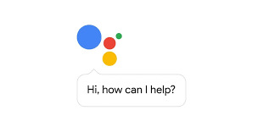

The **Google Assistant** is an artificial intelligence-powered virtual assistant developed by Google that is primarily available on mobile and smart home devices. Unlike the company's previous virtual assistant, Google Now, the Google Assistant can engage in two-way conversations.

Users primarily interact with the Google Assistant through natural voice, though keyboard input is also supported. In the same nature and manner as Google Now, the Assistant is able to search the Internet, schedule events and alarms, adjust hardware settings on the user's device, and show information from the user's Google account. Google has also announced that the Assistant will be able to identify objects and gather visual information through the device's camera, and support purchasing products and sending money, as well as identifying songs.

**Advantages of NodeMCU platform relative to the Arduino:**

* Low cost
* Integrated support for WIFI network
* Reduced size of the board
* Low energy consumption

**Blynk :**

**It works over the Internet t**his means that the hardware you choose should be able to connect to the internet. Some of the boards, like Arduino Uno will need an Ethernet or Wi-Fi Shield to communicate, others are already Internet-enabled: like the ESP8266, Raspberri Pi with WIFI dongle, Particle Photon or SparkFun Blynk Board. But even if you don’t have a shield, you can connect it over USB to your laptop or desktop .

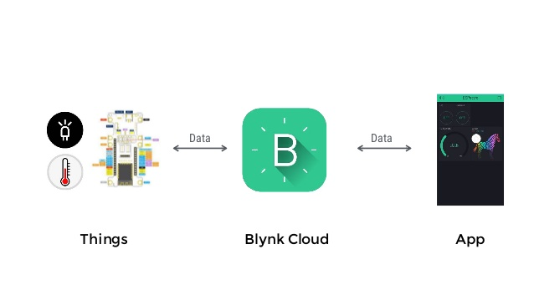

**Relay :**

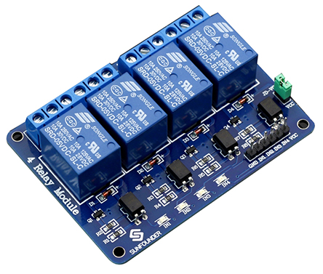

This is a 5V 4-channel relay interface board, and each channel needs a 15-20mA driver current. It can be used to control various appliances and equipment with large current. It is equipped with high-current relays that work under AC250V 10A or DC30V 10A. It has a standard interface that can be controlled directly by microcontroller.

## Principle:

From the picture above, you can see that when the signal port is at low level, the signal light will light up and the opto-coupler 817 (it transforms electrical signals by light and can isolate input and output electrical signals) will conduct, and then the transistor will conduct, the relay coil will be electrified, and the normally open contact of the relay will be closed. When the signal port is at high level, the normally closed contact of the relay will be closed. So you can connect and disconnect the load by controlling the level of the control signal port.

**Block Diagram:**

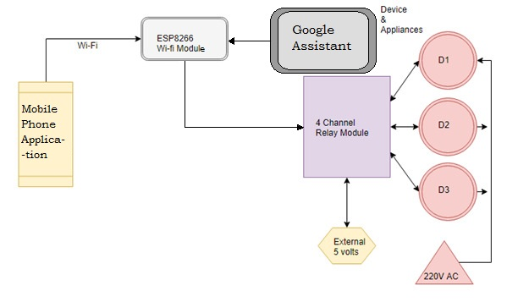

**Description of blocks :-**

1.Mobile application : Using this (**blynk**) application we can control the switch’s accordingly.

2.Node mcu (**Esp 8266** ) : the command from mobile application or goggle assistant (through blynk cloud ) is being processed accordingly and this signal is transmitted to relay.

3.Relay: it acts like a switch .It receive input from NodeMCU to respective relays(like relay 1, relay 2,..).the load is also connected to the load .So if relay is turn on then the load will be activated and vice versa

**Flow chart:**

IFTTT (Google Assistant)

NodeMCU

Relay

Blynk

Home Appliances

(bulb, fan)

**Conclusion:**

The purpose of the project is to construct an user friendly wireless home automation system. The **WIFI** connection is going to replace the wired connections that we used to have in our households . We can switch on and off almost all the in-house electronic instruments with the help of a simple mobile application.

**Work done in phase 1:**

Gaining basic knowledge, studying **WIFI** controlled automation techniques, study of Arduino programming language, NodeMCU, relay, building connections between NodeMCU and relay and semester end report submission.

**Work to be done in phase 2:**

•In future, we can become more flexible by manipulating and controlling the appliances in a more detailed manner. For example, we can change the speed of fan, increase or decrease the intensity of light etc.

•The implementation of sensors like temperature sensor, is the next step we are looking at. It will inform the owner if there is any sudden change in temperature in the room and can take necessary actions.

•A major part in home automation and wireless control is enhancing security inside the house. Installation of **PIR** sensor can alarm the owner about any unexpected movement inside the house.

**Annexure I**

**NodeMCU:**

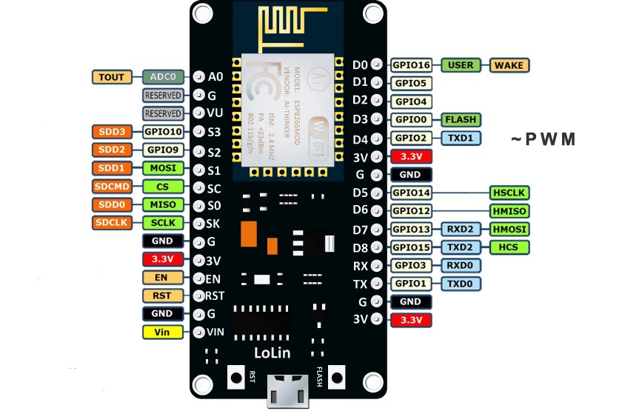

## The ESP8266 as a microcontroller – Hardware

### Digital I/O

The ESP8266 has digital input/output pins (I/O or GPIO, General Purpose Input/Output pins). As the name implies, they can be used as digital inputs to read a digital voltage, or as digital outputs to output either 0V (sink current) or 3.3V (source current).

#### Voltage and current restrictions

The ESP8266 is a 3.3V microcontroller, so its I/O operates at 3.3V as well. The pins are **not 5V tolerant, applying more than 3.6V on any pin will kill the chip.**

The maximum current that can be drawn from a single GPIO pin is **12mA**.

#### Usable pins

The ESP8266 has 17 GPIO pins (0-16), however, you can only use 11 of them, because 6 pins (GPIO 6 - 11) are used to connect the flash memory chip. This is the small 8-legged chip right next to the ESP8266. If you try to use one of these pins, you might crash your program.

GPIO 1 and 3 are used as TX and RX of the hardware Serial port (UART), so in most cases, you can’t use them as normal I/O while sending/receiving serial data.

#### Boot modes

Some I/O pins have a special function during boot: They select 1 of 3 boot modes:

| **GPIO15** | **GPIO0** | **GPIO2** | **Mode** |
| --- | --- | --- | --- |
| 0V | 0V | 3.3V | Uart Boot loader |
| 0V | 3.3V | 3.3V | Boot sketch (SPI flash) |
| 3.3V | X | x | SDIO mode (not used for Arduino) |

### Analog input

The **ESP8266** has a single analog input, with an input range of 0 - 1.0V. If you supply 3.3V, for example, you will damage the chip. Some boards like the NodeMCU have an on-board resistive voltage divider, to get an easier 0 - 3.3V range. You could also just use a trim pot as a voltage divider. The ADC (analog to digital converter) has a resolution of 10 bits.

**Communication**

#### Serial

The ESP8266 has two hardware UARTS (Serial ports):  
UART0 on pins 1 and 3 (TX0 and RX0 resp.), and UART1 on pins 2 and 8 (TX1 and RX1 resp.), however, GPIO8 is used to connect the flash chip. This means that UART1 can only transmit data.

**REES52 Opto-coupler 4 Channel** :

This is a low level 5V 4-channel relay interface board, and each channel needs a 15-20mA driver current. It can be used to control various appliances and equipment with large current. It is equipped with high-current relays that work under AC250V 10A or DC30V 10A. It has a standard interface that can be controlled directly by microcontroller. This module is optically isolated from high voltage side for safety requirement and also prevent ground loop when interface to microcontroller

**Input:**

VCC: Connected to positive supply voltage (supply power according to relay voltage).

GND: Connected to supply ground.

IN1: Signal triggering terminal 1 of relay module

IN2: Signal triggering terminal 2 of relay module IN

IN3: Signal triggering terminal 3 of relay module

IN4: Signal triggering terminal 4 of relay module

Output: Each module of the relay has one NC(normally close) one NO(normally open) and one COM(Common) terminal.

So there are 4NC, 4 NO and 4 COM of the channel relay in total. NC stands for the normal close port contact and the state without power. NO stands for the normal open port contact and the state with power. COM means the common port. You can choose NC port or NO port according to whether power or not.

**Annexure II**

**CODE:**

#define BLYNK_PRINT Serial //Defines the object that is used for printing

#include <ESP8266WiFi.h>

#include <BlynkSimpleEsp8266.h> //This library provides ESP8266 specific Wi-Fi routines we are calling to connect to network

// Go to the Project Settings (nut icon).

char auth[] = "c918543ff45d4bf1be87a9225100"; // You should get Auth Token in the Blynk App

char ssid[] = "roycreation"; //your WiFi credential

char pass[] = "happynewyear"; //Set password to "" for open networks

void setup()

{ // Debug console

Serial.begin(9600); // Sets the data rate in bits per second (baud) for serial data transmission

Blynk.begin(auth, ssid, pass);

}

void loop()

{

Blynk.run();

**Annexure III**

**Components list** **Cost of purchase (in** **)**

|  |  |
| --- | --- |
| ESP8266 NodeMCU WIFI Development Board | 399 |
| REES52 Opto-coupler 4 Channel **5V Relay Module Relay** | 299 |
| Bulb holder | 15 |
| Wire(5m) | 35 |

**References**

1. **Charith Perera**, Student Member, IEEE, Arkady Zaslavsky, Member, IEEE, “Context Aware Computing for The Internet of Things: A Survey”. IEEE COMMUNICATIONS SURVEYS & TUTORIAL
2. **Bill N. Schilit, Norman Adams**, and **Roy Want**, “Context-Aware Computing Applications”.
3. **Inderpreet Kaur**, “Microcontroller Based Home Automation System with Security” at IJACSA) International Journal of Advanced Computer Science and Applications. Vol.1 , No. 6, December 2010.
4. Paul Jasmin Rani(student member IEEE) ; Jason Bakthakumar Voice controlled home automation system using Natural Language Processing (NLP) and Internet of Things (IoT).
5. Abdul Aziz Md (lecturer, CSE dept RGUKT,APIIIT ), “cost effective voice control home automation using IOT”.
6. Design of an Intelligent Voice Controlled Home Automation System Sonali Sen, Shamik Chakrabarty, Ankita Bhaumik, Department of Computer Science, St. Xavier’s College, Kolkata
7. S.P. Pande, Prof. Pravin Sen, “Review On: Home Automation System For Disabled People Using BCI” in IOSR Journal of Computer Science (IOSR-JCE) e- ISSN:2278-0661, p-ISSN: 2278-8727 PP 76-80.
8. Basil Hamed, “Design & Implementation of Smart House Control Using LabVIEW”.
9. Basma M. Mohammad El-Basioni1, “Smart HomeDesign using Wireless SensorNetwork and Biometric Technologies” at Volume 2, Issue 3, March 2013.
10. Jayavardhana Gubbi, ,Rajkumar Buyya, Slaven Marusic,a Marimuthu Palaniswamia, “Internet of Things (IoT): A Vision, Architectural Elements, and Future Directions”.